Chapter 3, Solution 6.

Solve for V₁ using nodal analysis.

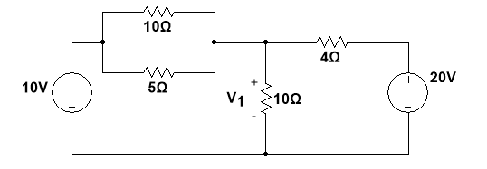

Figure 3.55
For Prob. 3.6.

Step 1. The first thing to do is to select a reference node and to identify all the unknown nodes. We select the bottom of the circuit as the reference node. The only unknown node is the one connecting all the resistors together and we will call that node V₁. The other two nodes are at the top of each source. Relative to the reference, the one at the top of the 10-volt source is +10 V. At the top of the 20-volt source is +20 V.

Step 2. The 10 Ω and 5 Ω resistors are in parallel. Solve for the equivalent resistance.

Step 3. Setup the nodal equation (there is only one since there is only one unknown).

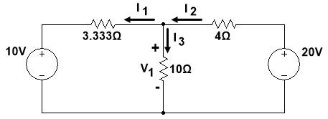

Step 4. Simplify and solve.

or
V₁ = 12.307 V

The answer can be checked by calculating all the currents by substituting in 12.307 V for V₁ and verifying the original node equation adds up to zero.

